The purpose of NIST Virtual Factory Testbed is to develop a system methodology and software framework in which to conduct analysis and compute optimizations of factory performance. The long-term strategic goal of the project is to develop an automated approach to optimization of production systems for more efficient operation. Given that NIST itself only has a small manufacturing job shop, the Virtual Factory Testbed will be used in the study of a broader range of production and would greatly assist in the ability to measure and optimize a multitude of manufacturing scenarios. Ultimately, the ability to study a broader range of production would be of greater use to NIST’s industrial manufacturing partners.

The advent of improved factory data collection offers a prime opportunity to automate the optimization of factory operations. However, the use of the factory data in analysis tools presumes the existence of a complementary production model, which currently is not a valid assumption, as the development of such models requires so much time and effort that it has not proven worth the cost. Therefore, automated data acquisition, automated generation of production models, and the automated integration of data into the production models are required for any optimization analysis to be timely and cost effective. Intuitively, the heavy use of automation will keep the analysis cost-effective and timely, but automated factory optimization poses some daunting technology challenges. The technology to achieve automated factory optimization requires automated data acquisition, automated factory model generation and automated production analysis. It is felt that Core Manufacturing Simulation Data offers a good technology to optimizing production, especially established manufacturing systems.

Core Manufacturing Simulation Data
Core Manufacturing Simulation Data (CMSD) specification is an information model made up of neutral definitions of a core set of manufacturing entities that are commonly used in manufacturing-oriented simulations. The purpose of CMSD is to facilitate the definition/exchange of manufacturing simulation related information for/between simulations and other manufacturing applications. CMSD provides the information in which to model such collected data but can be associated with one or more different manufacturing domains such as process planning, scheduling, inventory management, production management, or supply chain management.

The major components of CMSD relevant to the NIST virtual testbed include :

- Part, part type, BOM, and inventory data

- Resource, resource class, setup, and employee skill data

- Process plan, maintenance plan, and shift related data

- Order, job, and schedule related data

The goal of the NIST virtual testbed is to improve production operation by quickly modeling the production using CMSD, ascertaining and mapping the production data into the CMSD model, and incorporating model and production data to improve manufacturing.

CMSD Overview
The Enterprise domain is responsible for handling process customer orders and deciding to make or buy parts. The processing of customer orders triggers the creation of a unique part order (or workorder) within the Manufacturing Execution System (or production system). The creation of a part order (e.g., 10 front bumpers, 12 side panels) is incumbent on the knowledge on how to build the parts on some set of equipment (abstract process plan), the part definition(revision, part and quality) and part programs (how to make the part). All these are combined into jobs to make the parts (and may be scheduled). Of course, a job could describe not only production, but quality, inventory, or maintenance tasks. But in our case, we want a complete model of production operation so we will initially focus on production.

In Figure 1, a part is assumed to be a finished product that was produced or that can be used in production activities as raw material or a work in--progress component. Many different kinds of information can be specified for a part, such as, information about the production status of a part, the named category of parts that a specific part belongs to, the sub-component parts used to create this part, the process that can be used to create the part, and some basic characteristics of this Part. For a part, there is also a Planned Process Plan, which holds a list of Process objects in some sequence. This sequence can be used to describe the routing of a Part object. Each Process class holds a list of the Part Type that it requires for processing, as well as the products it creates. The Process class also holds a list of the resources required for processing. These resources can include physical locations (e.g. machines) and mobile resources (e.g. laborers or work fixtures).

In the scenario, a customer orders enters the system and triggers a part order. To match our case study discussed later, we will assume that the part order will contain only one type of part, a fixed number of parts will be made per day, and that this part will be made based on a abstract process plan, a part definition (revision and associated resources and part programs) and part programs (or recipes) to make part on a series of equipment. After all this information is collated, a job will be generated containing the part and a process plan to describe the potential sequence through a set of resource types. This process plan will serve as the scheduled routing of the raw material to become a part. The alternate routing serves in case to reroute if a broken equipment arises - however, in our case study, this is not a concern as the primary equipment will be used and fixed if broken. Using shop-floor data, the simulation will then make the part and buffer the finished part based on the data.

In Figure 1, the concept of resource breaking down is based on production task -- even though maintenance information is necessary to differentiate the equipment and the mechanic must replace or fix the broken equipment even though from a production standpoint, the piece of equipment and time to break and time to repair are important performance indicators.

Figure 1 Job Life Cycle

The schema of CMSD is shown below:

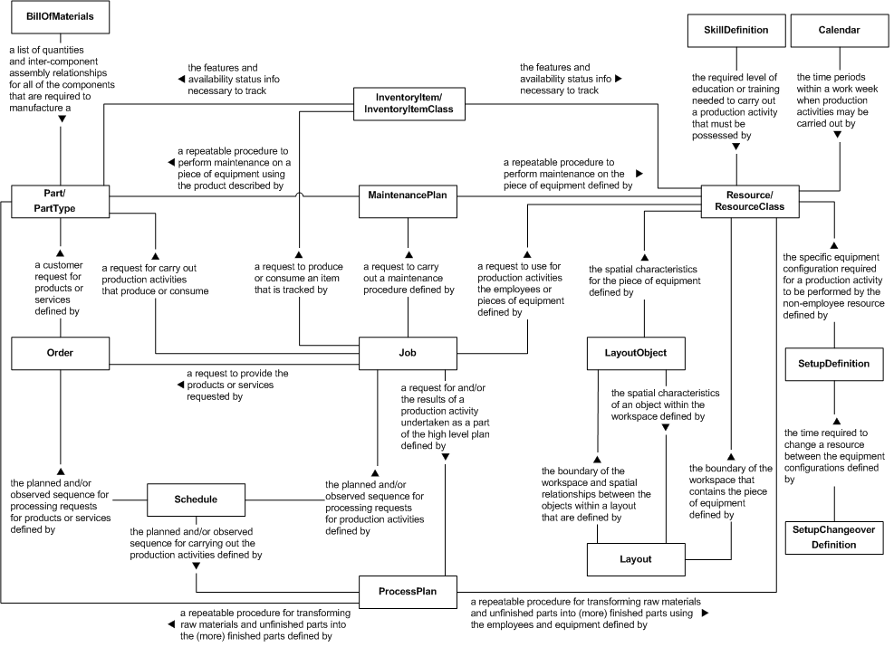

The core elements of CMSD simulations is the part.

